Online Fax

Overview

Contents
Messaging 2
Quick Pitch 2
Top-line Benefits 2
Detailed Benefits 3
Encrypted Online Fax Benefits 3
Multi-User Online Fax Benefits 3
Features 5
Standard Features Overview 5
Customer Experience 7
Standard Online Fax 7
Encrypted Online Fax 12
Sales Support – Standard Online Fax 16
Probing Questions 16
Selling Points 16
Objection Handlers 17
Sales Support – Encrypted Online Fax 18
Probing Questions 18
Objection handlers: 18
Frequently Asked Questions 20
Standard Online Fax 20

Messaging

Quick Pitch
Standard Online Fax
Securely send and receive faxes, anywhere, on any device.
Online Fax allows you to send and receive faxes from your email, mobile device or web browser, without using a physical machine or a second phone line.
Online Fax provides small businesses mobility, security, and reassurance that your important documents are in safe hands. With cover pages, email confirmations and easy online management, you get all of the functionality of fax, and more.

Encrypted Online Fax
Securely send and receive faxes, anywhere, on any device with Encrypted Online Fax.
Be sure your business is protected maintaining required levels of security and archiving across industries including healthcare, law, realty, financial and other industries requiring data security and confidentiality.
Encrypted Online Fax provides businesses convenience and mobility without compromising security. Eliminate the need for a physical fax machine, a second phone line and lost productivity having to monitor your fax machine to receive documents.
Fax notifications are securely received in your personal email inbox via a local or North American-based toll-free number with easy access through a simple online interface ensuring the highest levels of security to ensure the privacy and confidentiality of all faxes. With cover pages, email confirmations and easy online management, you get all of the functionality of fax, and more.

Multi-User Online Fax
Introduce secure fax over email to your workforce.
Multi-User Online Fax is a scalable, secure fax solution for mid-to-large business. Online Fax offers a more cost-effective solution than traditional or server-based fax and the tools a growing mobile workforce now demands, while maintaining required levels of security, meeting HIPAA requirements and archiving.
Meeting the needs of those organizations that require high volume fax capabilities, fax usage is pooled allowing all users the ability to securely send and receive faxes using almost any file format through email and a simple online interface.
Avoid capital and maintenance costs while improving security and data retention. Multi-User Online Fax meets the technical and administrative requirements of HIPAA. Launch today, with no system integration required.

Top-line Benefits
- Save money: Eliminate costly machine maintenance, ink and toner, and monthly landline and long distance charges.
- Toll-free number included: Look professional. Use a dedicated toll free number to receive faxes to your Online Fax portal and email.
- Be mobile: Send and receive faxes through your email on your mobile device. Send almost any file format to a fax number.
- Improve productivity: Send and receive faxes anywhere with Internet access. Plus, send faces to multiple recipients at one using Outlook, Gmail or any other email client.
- Protect your business: Securely send statements, invoices, contacts, HR documents and more, reducing the risk of physical theft or loss. Digitally archive your documents on a secure server.

Detailed Benefits

Toll-free Fax Number | - Eliminates the requirement for a second land line  - Save on long distance charges  - Send and receive faxes anywhere in North America*
Easy-to-use Online Interface | - Manage faxes from anywhere online  - Send, receive and manage faxes  - Access faxes that are securely stored in your archive  - Full management of folders including inbox, sent faxes, outbox and archived faxes
Email Compatible | - Receive faxes right to your email inbox, i.e. Microsoft Outlook, Gmail, etc.  - Requires no extra software to be installed on your computer
Securely Store Received Faxes Online | - Faxes are archived and securely stored online for 30 days
File Support | - Send popular file formats including  - Microsoft Word, Excel and PowerPoint  - Adobe PDF  - JPEG and TIFF images
Additional Fax Features | - Add cover pages to your faxes  - Send a fax to up to 20 individual fax recipients  - Route incoming faxes to up to 5 fax recipients  - Receive email confirmations when faxes are successfully and unsuccessfully sent  - 5 attempt auto resend  - Real-time usage summary

Encrypted Online Fax Benefits

Toll-free Fax Number | - Eliminates the requirement for a second land line  - Save on long distance charges  - Send and receive faxes anywhere in North America**
Protect your business | - Meets the technical, operational and administrative requirements of HIPAA  - Ideal for any businesses required to send and receive confidential encrypted information
Anytime access | - Receive email notifications when you receive a new encrypted fax to any email inbox  - Access your faxes and archive via a secure Online Fax portal  - Send faxes to fax numbers via email

Multi-User Online Fax Benefits

Manage Multiple Users | - Eliminates the requirement for a second land line  - Save on long distance charges  - Send and receive faxes anywhere in North America**
Scalable Solution | - Scalable, cloud-based solution  - Allows multi-level admin and user access to a shared fax page allotment
Simplified Provisioning | - Encrypted data transmission and security update procedures  - User authentication, usage tracking and time-outs  - Audit trail and archiving, and disaster recovery protocol  - Physical security and access limitation
Secure and Reliable Transmissions | - Telecom-grade Session Initiation Protocol (SIP) trunking ensures data integrity and high fault tolerance  - Servers maintain a 99.9% uptime  - Meets the technical, operational and administrative requirements of HIPAA
Simplified Provisioning | - No system integration on customer side required  - Anywhere admin/user access through a Partner-branded simple online interface  - Eliminates hardware, software licensing, long distance, connectivity, network and other overheard costs accrued with a traditional fax or fax server infrastructure
Administrative Control and Flexible Plans | - Scalable packages with large user and volume capacity  - Multiple levels of admin and user profiles through single Admin Account Management  - Detailed, per fax number usage reporting for controllable cost management
Complete Mobile Access for Employees | - Inbound/outbound fax technology via email clients, mobile devices or an SSL secured, web-based application  - Eliminates geographical limitations in provisioning and ongoing productivity

Features

Standard Features Overview
Sending and Receiving Fax | - 1 toll-free fax number included with Online Fax package  - Send and receive fax to and from anywhere in North America*  - Receive faxes to up to 5 additional email addresses  - Send faxes from associated email addresses  - Send faxes via email to fax numbers  - Send faxes to multiple fax numbers via the online portal, and choose to include a cover page  - Send popular file formats including  - Microsoft Word, Excel and PowerPoint  - Adobe PDF  - JPEG and TIFF images  - Send up to three attachments, with a maximum file size 10MB  - All encrypted faxes are viewed over a secure connection; therefore, when you receive a fax, you will be notified by email and provided a link to view your fax. When using data-encryption, faxes cannot be sent or received through email as an attachment.
Online Management | - Secure login online interface to manage, send and receive faxes and set and manage your service preferences  - Download your faxes from the online user interface and save them to in PDF of TIFF format  - View monthly usage, your fax number, Inbox, Outbox, Archive and Contacts  - Add additional email addresses to send and receive faxes (up to 5 accounts for standard Online Fax)  - Search Inbox and Archive by fax number, Company, Contact or Date  - Edit your settings, including Company, Location, Phone, Fax, Email and Email signature  - Set cover page style preferences  - Choose to email copies of faxes that have exceeded their storage period  - Block specific fax number
Email Notifications | - Receive faxes in PDF or notifications of received faxes straight to your Inbox  - Receive email notifications when your outbound faxes are successfully sent  - Usage warnings are emailed at 80%, 90%, and 100%
Archiving | - Received faxes are digitally archived for 30 days (or up to 1 year for encrypted/multi-user)  - Access and download archived faxes through a secure online interface  - Search your archive by specifying date period, keyword, company and choose send, received or both sent and received faxes
Contacts | - Add contacts in your online portal, with details including Name, Company, Location, Phone, Description, Email  - Import contacts from a CSV file
*Standard Online Fax Toll-Free Number: Users can receive faxes from anywhere in the world that their fax number can be dialed to. For the case of Toll Free numbers the calls must originate in Canada or US. Send faxes anywhere in North America with the exclusion of the Virgin Islands. US Local Number: Send fax within Canada/US, with the exclusion of Puerto Rico and the Virgin Islands. Incoming from anywhere in the world.
**Encrypted/Multi-User Online Fax Toll-Free Number: Users can receive faxes from anywhere in the world that their fax number can be dialed to. For the case of Toll Free numbers the calls must originate in Canada or US. Send faxes anywhere in North America including Puerto Rico and Virgin Islands. US Local Number: Send fax within Canada/US, with the exclusion of Puerto Rico and the Virgin Islands. Incoming from anywhere in the world.

Customer Experience

Standard Online Fax
You will receive a Welcome email from containing your new fax number and password.
This email will include the link to the Online Fax login portal (image on left) where you can send, receive or view faxes.
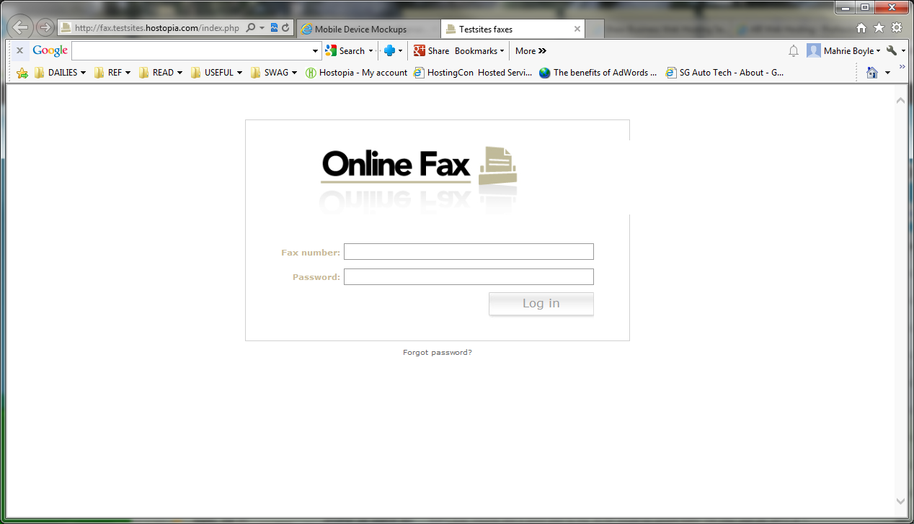
After logging in access your inbox, send a fax, archive, or manage your contacts. Your Online Fax portal includes a monthly meter usage at the top left so you always know how many pages have been sent in a given month.
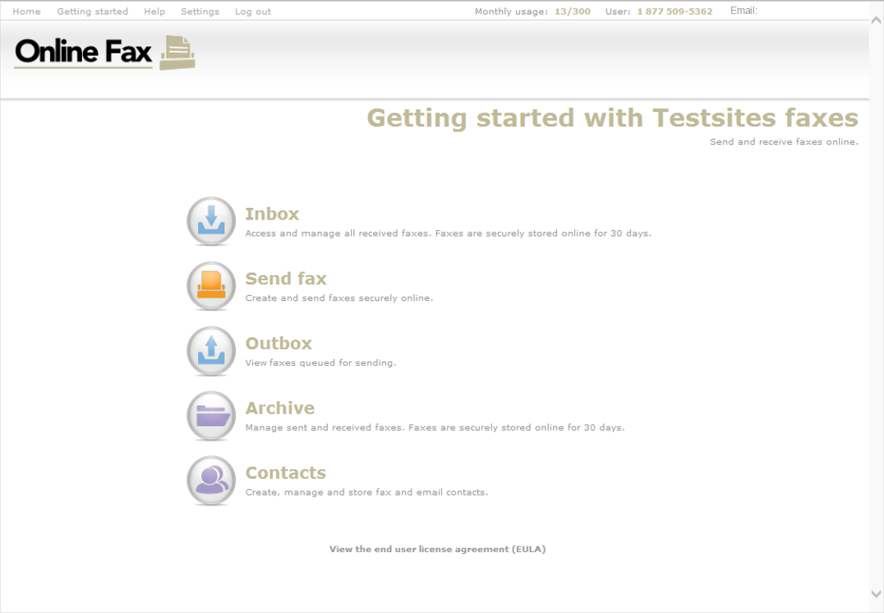
From the inbox you can view fax, rotate fax, email fax, download PDF, download TIFF, or move to archive.
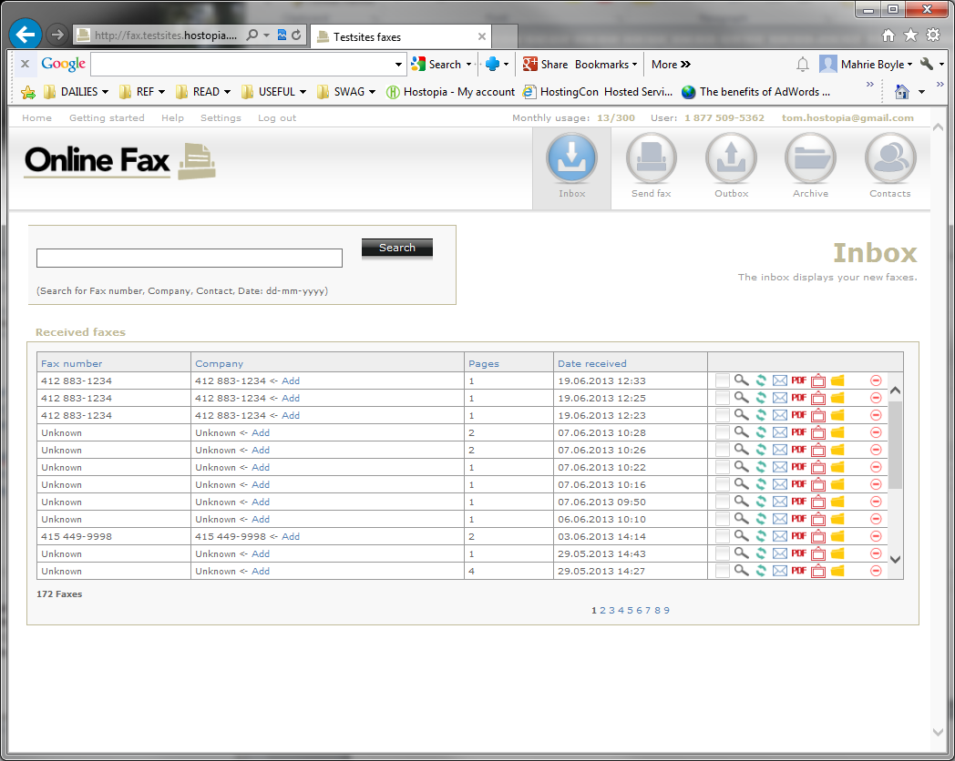
You will also receive email notifications when you receive a new fax.
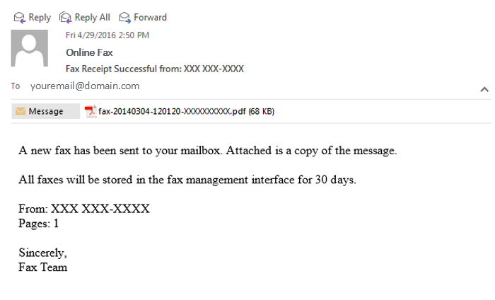
To send a fax, simply type in the destination fax number (or choose from the list of contacts), upload the document and click “send”. You have the choice to add a cover page.
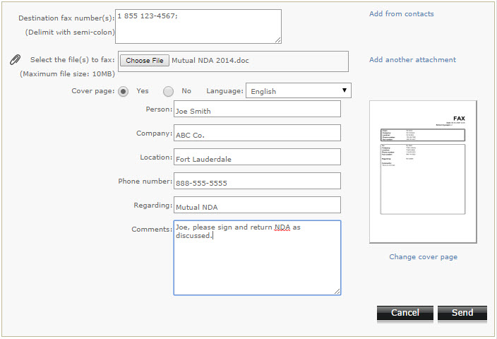
You will receive email confirmations for faxes sent successfully.
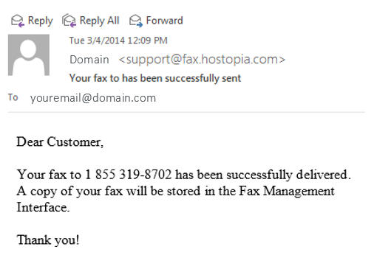
You can also send faxes through your email account. To send a new fax via email, begin by composing a new email. In the “To” field, enter the destination fax number followed by @fax.domain.com. Attach the document you would like to fax. You can send from any email client, with the email(s) associated to your account.
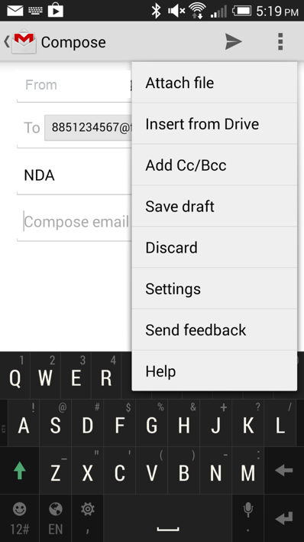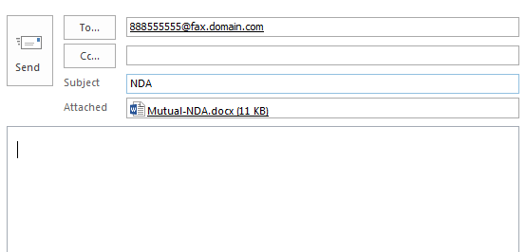
In your Archive, you can search sent and received faxes by keywords or other parameters.
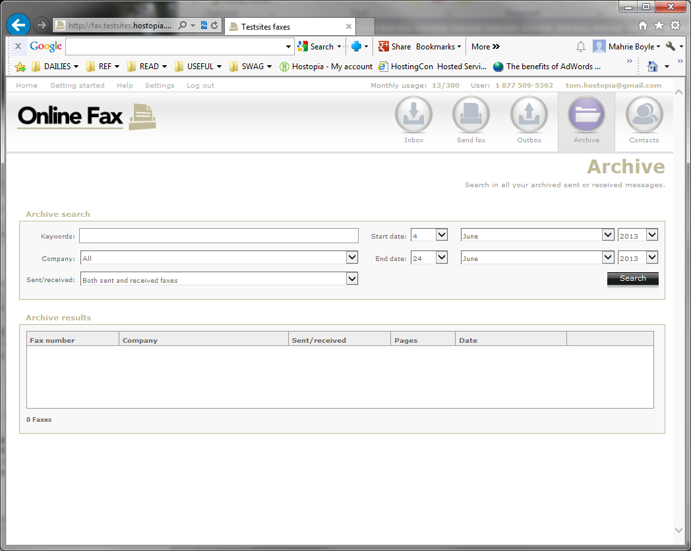
Under settings, set your contact details including your name, company and more.
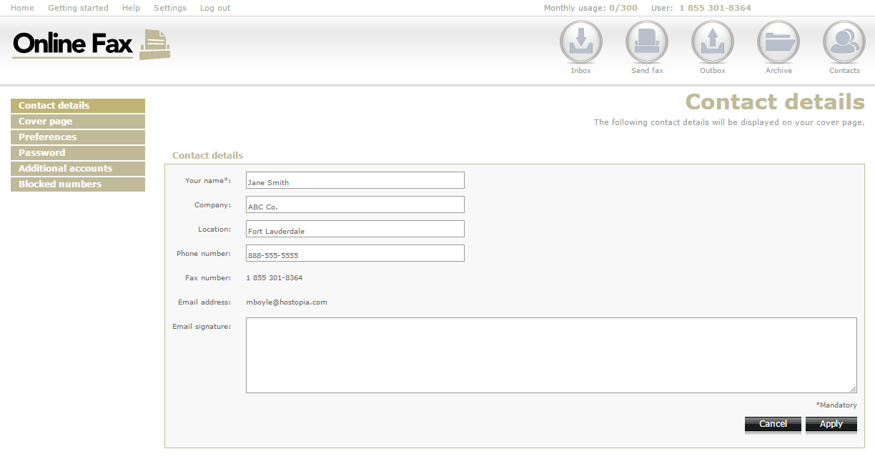
Set your cover page preference. You can also update your preferences, passwords and block numbers through your Settings.
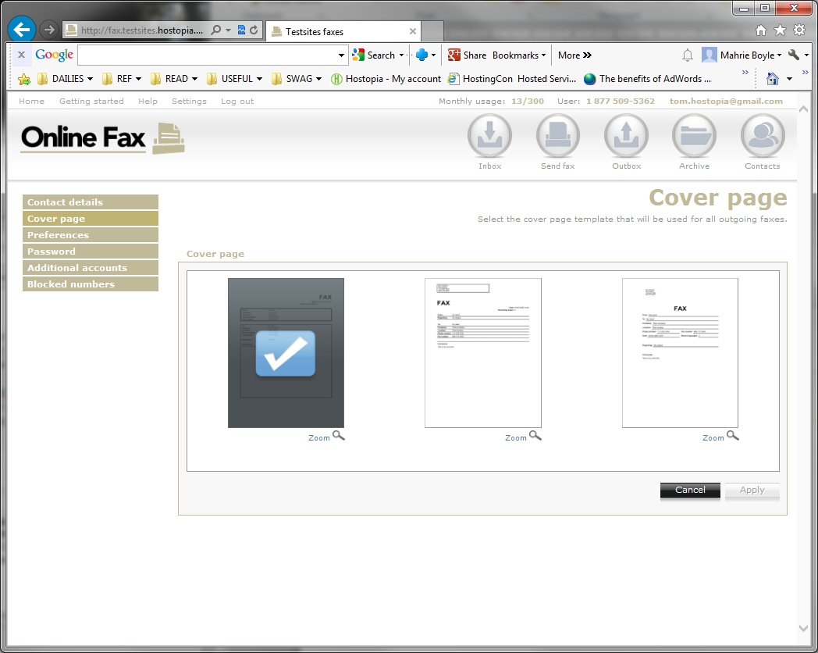
Add additional email addresses to your account, and choose whether each email receives faxes to your fax number or can send faxes via email.
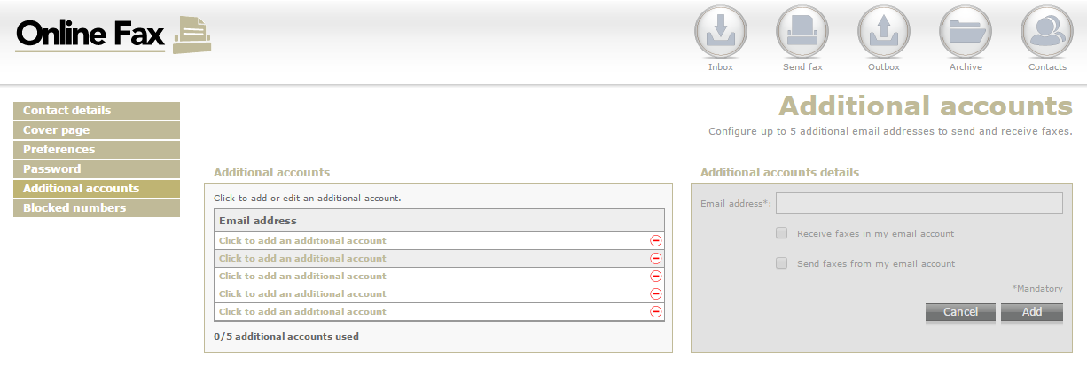

Encrypted Online Fax
You will receive a Welcome email from containing your new fax number and password.
This email will include the link to the Online Fax login portal (image on left) where you can send, receive or view faxes.

After logging in access your inbox, send a fax, archive, or manage your contacts. Your Online Fax portal includes a monthly meter usage at the top left so you always know how many pages have been sent in a given month.

From the inbox you can view fax, rotate fax, email fax, download PDF, download TIFF, or move to archive. You will also receive email notifications when you receive a new fax.


To send a fax, simply type in the destination fax number (or choose from the list of contacts), upload the document and click “send”. You have the choice to add a cover page.

You will receive email confirmations for faxes sent successfully.

In your Archive, you can search sent and received faxes by keywords or other parameters.

Under settings, set your contact details including your name, company and more.

Set your cover page preference. You can also update your preferences, passwords and block numbers through your Settings.

Add additional email addresses to your account, and choose whether each email receives faxes to your fax number or can send faxes via email.


Sales Support – Standard Online Fax

Probing Questions
Do you currently use a fax machine to send or receive faxes?

- Yes. Online Fax provides the same secure functionality of a fax machine, including a toll-free fax number, but WITHOUT the costly fax machine. That means no machine, no landline, no long distance, no paper or toner. You will receive faxes sent to your fax number as attachments in your email, and you can send faxes directly through your email.

- No. Even if you don’t fax every day, it’s incredibly useful to be able to share or access a fax number and be able to send faxes through your email. Invoices, HR, contracts, financial documents, even documents in your personal life, you’ll still require access to fax.

What type of business are you in?

Many industries have the need to send and receive confidential and sensitive data and Online Fax allows the secure transmission of documents through email or a convenient online interface instead of having to use a fax machine: Realtors, lawyers, insurance companies, mortgage brokerages, legal firms, health care organizations (doctor, dentist, long-term care, etc.), remote workers, take out establishments (restaurants, delis).

Business owners on the go or who have a mobile workforce will also benefit from the convenience of being able to send and receive fax from anywhere.

Selling Points
Save money: Eliminate costly machine maintenance, ink and toner, and monthly landline and long distance charges.
Toll-free number included: Look professional and easily receive fax via a dedicated toll-free fax number that delivers faxes to your Online Fax portal and email.
Be mobile: Send and receive faxes through your email on your mobile device. Send almost any file format to a fax number.
Improve productivity: Send and receive faxes anywhere with Internet access. Plus, send faces to multiple recipients at one using Outlook, Gmail or any other email client.
Close deals: Send and receive important documents straight through your email.
Protect your business: Securely send statements, invoices, contacts, HR documents and more, reducing the risk of physical theft or loss. Digitally archive your documents on a secure server.

Why should I choose Online Fax?
- Save on long distance costs as you can securely send and receive faxes anywhere in North America.
- Offer convenience for those that need to fax you. Get a dedicated toll-free fax number included, and receive faxes directly in your email.
- Easy to use. With Online Fax, you don’t need to install any hardware or software, you only need an Internet-enabled device; it can be your desktop, laptop, tablet or mobile.
- Improve Productivity. Be confident your faxes have been sent with auto-resend attempts and email confirmations.
- Digitize your communications. Send almost any file attachment as a fax, from your computer or mobile. Send popular file formats including Microsoft Word, Excel and PowerPoint, Adobe PDF, JPEG and TIFF images. All faxes are archived for 30 days.

Objection Handlers
I already have a fax machine.
Online Fax provides the same secure functionality of a fax machine, including a toll-free fax number, but WITHOUT the costs of maintaining a fax machine. That means no machine, no landline, no long distance, no paper or toner. You will receive faxes sent to your fax number as attachments in your email, and you can send faxes directly through your email.
Did you know that with Online Fax:
- You no longer need a fax machine or need to pay for an additional phone line.
- You no longer need to circle the fax machine until a fax comes in or is sent, you are conveniently notified in the form of an email.
- You can check faxes on the road, in a meeting or while at home. It’s convenient and as mobile as you are.
I have confidential faxes to send.
You can send and receive faxes securely to anyone within the United States and Canada through your email and you never need to worry about confidential faxes coming in through to the fax machine when you are not there to pick them up. Save time from monitoring your fax machine. Online Fax delivers faxes straight to your email inbox. Faxes are archived and securely stored online for 30 days.
I’m not sure if I can afford switching my fax solution right now.
Online Fax will actually help you save money. With Online Fax you eliminate the cost of having to maintain and monitor a physical fax machine, you no longer need to pay for an additional phone line, plus you reduce your paper and toner usage.

I use business email to send confidential documents.
Currently there are several businesses that will only accept and send documentation through faxing. Therefore we recommend that all small businesses have a way to send documents through a fax solution in addition to their business class email.

Sales Support – Encrypted Online Fax

Probing Questions
Does your organization need to adhere to HIPAA standards to ensure data security and confidentiality?
Organizations and agencies in the healthcare industry need to send patient information according to HIPAA requirements. Hospitals, clinics, doctor offices, labs, long-term care institutions, are examples of organizations regulated by HIPAA.
Encrypted Online Fax meets the technical, operational and administrative requirements of HIPAA.

Does your organization have a high-volume of faxes sent and/or received?
High fax volume leads to more paper, which in turn, leads to lost or misplaced faxes and unsecured confidential information.
Encrypted Online Fax allows all faxes to be delivered in a secure manner, directly to your account, eliminating the need to sort faxes after delivery and ensures that only the intended recipient receives the fax.

Does your shared fax machine pose security risks?
Ensure you have access to all your critical faxes at all times of the day regardless of where you are.
Encrypted Online Fax offers the highest confidentiality by notifying you directly by email and providing access to faxes through your secure Online Fax portal.

Objection handlers:
I already have a fax machine.
Online Fax provides the same secure functionality of a fax machine, including a toll-free fax number, but WITHOUT the costs of maintaining a fax machine. That means no machine, no landline, no long distance, no paper or toner. You will receive faxes sent to your fax number as attachments in your email, and you can send faxes directly through your email.
Did you know that with our Encrypted Online Fax solution:
- You meet HIPAA security and confidentiality requirements and therefore avoid potential data breaches resulting in hefty regulatory fines.
- You can port your existing fax number, or receive a new fax number without having to lease or purchase any faxes equipment. You will be able to send and receive documents as fax through your computer or mobile device.
- You can access faxes wherever you are – all you need is an Internet connection.
- Online Fax also reduces your paper and toner usage, which helps save your money and the environment.
- You can check faxes on the road, in a meeting or while at home. It’s convenient and as mobile as you are.
I have confidential faxes to send.
Encrypted Online Fax meets the technical, operational and administrative requirements of the Health Insurance Portability and Accountability Act (HIPAA).
Encrypted Online Fax follows the Internet’s highest security protocols so your business can be secure and protected.
You can send and receive faxes securely to anyone within the United States and Canada through your Encrypted Online Fax Portal and you never need to worry about confidential faxes coming in through an old fax machine when you are not there to pick them up. Save time from monitoring your fax machine. Faxes are archived and securely stored online for 1 year.
I’m not sure if I can afford switching my fax solution right now.
Encrypted Online Fax can actually save you money. With Encrypted Online Fax you eliminate the cost of having to maintain and monitor a physical fax machine, plus you reduce your paper and toner usage.
You’ll also help your business reduce legal risk. Documents stored on the Encrypted Online Fax Portal are encrypted and securely stored.

Frequently Asked Questions

Standard Online Fax
What is the Online Fax application?
The Online Fax application is a web-based tool that you can use to send, receive and view your faxes online. Faxes will also get sent to your email inbox so you can view them there as well. You can also use the Online Fax application to manage your account settings.
Do I need to download any software or make any installations?
There is no need for installation or software. Online Fax is entirely web-based and ready to go once you sign up.
How do I see my faxes?
As an Online Fax customer, you have the option to view your faxes in two ways. You can view your faxes through your email or you can log into the Online Fax application to access your faxes.
Methods to view your faxes:
Through the Online Fax application.
- Log into your Online Fax Interface:
- Enter your Online Fax Number (sent to you when you sign up for the service).
- Enter your Online Fax Password and click the Login Button.
- Any faxes that you have received can be viewed for a period of 1 year, unless they have previously been deleted.
- To open a fax, mouse over the fax to either see a preview of it, or select the view button. Once the fax is open, you can click the Download button and save the fax to your computer.
Through your email (Standard Online Fax)
- Open the email message that you have received.
- Double-click on the attachment.
Please note:
- All faxes received in your inbox will be sent in .PDF or .TIFF format. You can configure which format you prefer to receive your faxes in by logging into the Online Fax application and changing your preferences.
How will I know when someone sends me a fax message?
When someone sends you a fax, the message is delivered to the email address on your account and also into the Online Fax application. Please see the information below for more details:
- Your faxes will come from the email address fax@fax.domain.com.
- The subject line of your email will be Fax: Number Sent dd.mm.yyyy time. (example - Fax: 9056731331 11.07.2008 10:04)
- Faxes are also delivered to the Online Fax application. If you log into your Online Fax account and click on the Inbox, you will be able to view all new and saved faxes. Faxes are received and stored for up to 1 year or until you delete them within the 1 year period.
Can anyone send me a fax or must they be Online Fax subscribers?
Anyone can send a fax to your Online Fax number. Potential senders do not need to be Online Fax subscribers, but they do need to be located in the United States or Canada.
Can I reply to a fax message I received?
Your faxes are sent to your email from fax@fax.domain.com. If you click "Reply" in the email you received from Online Fax, the message will be sent back to Online Fax as undeliverable. You will want to ensure that you send a new fax to the intended recipient.
How can I make sure the faxes I sent were successful?
When you send a fax you will receive a Send Receipt to your email confirming transmission.
How can I change my fax file format for receiving faxes?
To change the file format log into the Online Fax application and click on Settings, then click on Preferences. You will see Attachment Format options. Select either PDF (.pdf) or TIFF (.tif).
You can view your incoming faxes in two different formats:
- TIFF which supports multi-page images. A TIFF file is denoted by the .tif extension and can be opened in many programs, including Imaging (the default Windows TIFF viewer) and Online Fax.
- PDF which can be viewed with the Adobe Acrobat Reader software. A PDF file is denoted by the .pdf extension.
Why are my faxes difficult to read?
The fax message you receive is identical to what was sent by the sender of the fax. If the quality of your fax is poor, it is likely a problem on the sender's end. Please have the sender resend the fax using a higher resolution on their fax machine, such as Photo Mode.
Someone sent me a fax. Why haven't I received it?
There are a few reasons you may not be receiving your fax messages:
- Your email provider maybe experiencing problems: Occasionally, your email provider can experience problems sending certain files through to your email. Because your faxes are sent to your email as attachments, this may cause a problem with delivery. If you are experiencing this problem please check to see if your fax has been received within the Online Fax application.
- The sender has the wrong fax number: Occasionally a sender will send to the wrong fax number. If you have not received a fax you were expecting, please have the sender check the number and try again.

<< DOCUMENT END >>

